Parkinson’s disease prediction model

Student Name: Shramika Shirke
Student id: 77417
Subject: Big Data Analytics; SPEC: Applied Data Science and AI (CIM2SE019CI)

1. Introduction to the Project
Parkinson’s disease is a progressive neurological disorder that affects movement, speech, and motor control. Early detection of Parkinson’s disease is important because it allows timely medical intervention and improves patient quality of life. With the advancement of data analytics, machine learning techniques can help detect Parkinson’s disease using biomedical voice measurements.
This project focuses on building a Parkinson’s disease prediction model using SAS. The main objective is to analyze voice-based features such as frequency variation, amplitude variation, and noise-related measures to classify whether a person is healthy or affected by Parkinson’s disease.
The project follows a complete analytics workflow, including:
- Data import and cleaning
- Variable transformation and renaming
- Feature engineering
- Weight of Evidence (WOE) calculation
- Normalization of variables
- Train test plit
- K-fold cross-validation
- Logistic regression modeling
- Model evaluation using confusion matrix, ROC curve, and AUC
- Prediction for new patients
The target variable in this data set is status, where:
- 1 = Parkinson’s disease patient
- 0 = Healthy individual
The dataset contains biomedical voice measurements, which are useful for identifying patterns linked to Parkinson’s disease. Variables such as frequency jitter, amplitude shimmer, and harmonic-to-noise ratio provide insights into vocal instability, which is a key symptom of Parkinson’s.
This dataset is suitable because:
- It contains real-world biomedical features
- It supports binary classification
- It allows use of advanced analytics like WOE, ROC, and cross-validation
- It is ideal for demonstrating a complete SAS modeling pipeline

2. Explanation Code with Results
The first step in this project is importing the Parkinson’s disease dataset into SAS using PROC IMPORT. The dataset is stored in CSV format, so the option DBMS=CSV is used to specify the file type. The GUESSINGROWS=MAX option allows SAS to scan all rows before assigning variable types, which improves accuracy when dealing with numeric and character variables.
After importing the data, a sample of the dataset is displayed using PROC PRINT. This step is very important because it ensures that the dataset has been imported correctly and that all variables are properly recognized.
The dataset consists of multiple biomedical voice measurements such as frequency, jitter, shimmer, and noise-related variables. These variables help distinguish between healthy individuals and patients with Parkinson’s disease.
Code:
proc import datafile="/home/u64477338/sasuser.v94/sas project ss/Parkinsson disease.csv"
out=parkinsons_raw
dbms=csv
replace;
guessingrows=max;
run;
proc print data=parkinsons_raw(obs=10);
title "Raw Data Sample";
run;
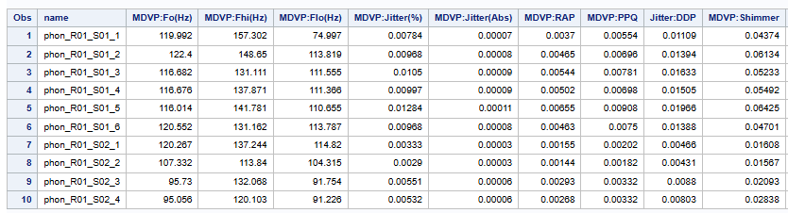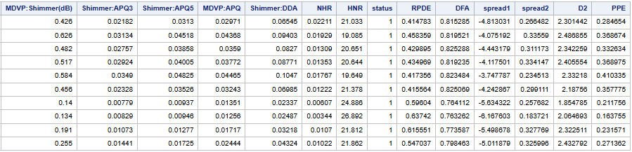
Note: This dataset consists of 24 parameters hance all of them can’t be capture in one frame I had divided into 2 fragments.
The original dataset contains variable names with special characters such as colons (:) and parentheses (()), which can cause issues during analysis. To solve this, the variables are renamed using SAS name literals (variable’s) syntax.
For example:
- MDVP:Fo(Hz) → avg_fre
- MDVP:Fhi(Hz) → max_fre
This step improves readability and makes the variables easier to use in modeling and transformations.
Code:
proc contents data=parkinsons_renamed;
title "Dataset After Renaming";
run;
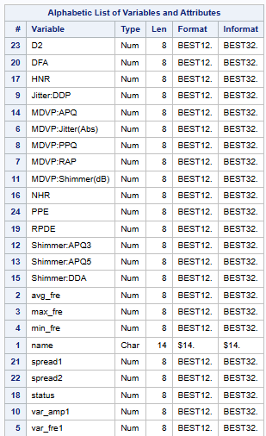
After renaming, PROC CONTENTS is used to verify that variables have been correctly renamed.
In this step, the dataset is cleaned to remove invalid observations. Specifically, rows with missing values in the target variable (status) are removed.
Cleaning is essential because missing values can negatively affect model accuracy and cause errors during model training.
PROC FREQ is used to check the distribution of the target variable. This helps confirm:
- Whether the dataset is balanced or imbalanced
- The number of Parkinson’s vs healthy cases
Code:
data parkinsons_clean;
set parkinsons_renamed;
if missing(status) then delete;
run;
proc freq data=parkinsons_clean;
title "Status Distribution";
tables status;
run;
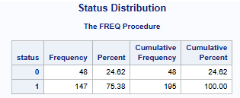
Continuous variable avg_fre is converted into categorical bins:
- Low
- Medium
- High
Binning is important because WOE transformation works on categorical groups rather than continuous values.
This step also helps in interpreting the variable because it shows how different ranges of frequency relate to disease classification.
Code:
data parkinsons_binned;
set parkinsons_clean;
length avgfre_bin $20;
if avg_fre < 120 then avgfre_bin = "Low";
else if avg_fre < 180 then avgfre_bin = "Medium";
else avgfre_bin = "High";
run;
proc freq data=parkinsons_binned;
title "Binning vs Status";
tables avgfre_bin*status;
run;

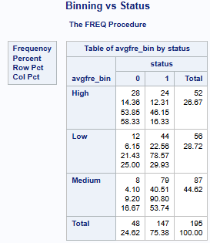
Weight of Evidence (WOE) is used to convert categorical variables into numerical values that reflect their relationship with the target variable.
This transformation provides:
- Better model performance
- Improved interpretability
- A monotonic relationship with the target
Code:
proc sql;
create table woe_table as
select avgfre_bin,
sum(case when status=0 then 1 else 0 end) as Good,
sum(case when status=1 then 1 else 0 end) as Bad
from parkinsons_binned
group by avgfre_bin;
quit;
proc print data=woe_table;
title "WOE Raw Counts";
run;
proc sql;
create table totals as
select sum(Good) as total_good,
sum(Bad) as total_bad
from woe_table;
quit;
data woe_final;
if _n_=1 then set totals;
set woe_table;
good_dist = Good/total_good;
bad_dist = Bad/total_bad;
if good_dist>0 and bad_dist>0 then WOE = log(good_dist/bad_dist);
run;
proc print data=woe_final;
title "WOE Final Table";
run;
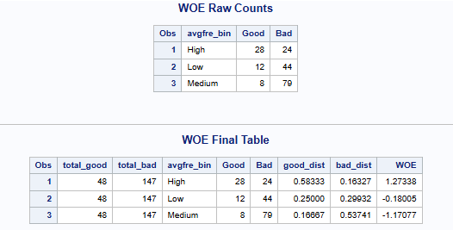
- After calculating WOE values, they are merged back into the main dataset.
- Each observation now contains a corresponding WOE value based on its frequency bin. This allows the logistic regression model to use the WOE-transformed information instead of raw categorical data.
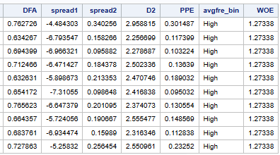
Min-max normalization is applied to variables such as:
- avg_fre
- max_fre
Normalization ensures that all variables are on the same scale (between 0 and 1), preventing variables with large values from dominating the model.
Code:
proc means data=parkinsons_woe noprint;
var avg_fre max_fre;
output out=norm min=min1 min2 max=max1 max2;
run;
data parkinsons_final;
if _n_=1 then set norm;
set parkinsons_woe;
norm_avg = (avg_fre-min1)/(max1-min1);
norm_max = (max_fre-min2)/(max2-min2);
run;
proc print data=parkinsons_final(obs=10);
title "Final Dataset Sample";
run;
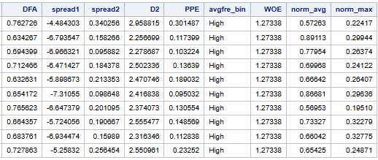
The dataset is divided into:
- 80% training data
- 20% test data
Training data is used to build the model, while test data is used to evaluate performance.
This step ensures that:
- The model generalizes well
- Overfitting is minimized
Code:
proc surveyselect data=parkinsons_final
out=train_cv
samprate=0.8
seed=123
outall;
run;
data train_data test_data;
set train_cv;
if Selected=1 then output train_data;
else output test_data;
run;
proc freq data=train_data;
title "Training Data Distribution";
tables status;
run;
proc freq data=test_data;
title "Test Data Distribution";
tables status;
run;

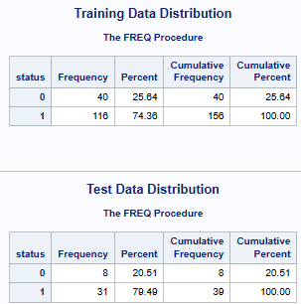
K-fold cross-validation is used to improve model reliability.
The training data is divided into 5 folds:
- Each fold is used once as validation data
- Remaining folds are used for training
This helps:
- Reduce overfitting
- Provide better performance estimation
Code:
data train_cv;
set train_data;
Fold = mod(_n_-1,5)+1;
run;
proc freq data=train_cv;
title "Fold Distribution";
tables Fold;
run;
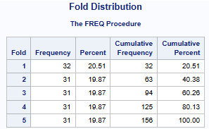
A logistic regression model is built using:
- Normalized variables
- WOE variable
Logistic regression is suitable because the target variable is binary.
This model estimates the probability that a patient has Parkinson’s disease.
Code:
%macro kfold;
%do k=1 %to 5;
data cv_train cv_valid;
set train_cv;
if Fold=&k then output cv_valid;
else output cv_train;
run;
proc logistic data=cv_train descending;
title "Fold &k Training Model";
model status = norm_avg norm_max WOE;
run;
proc logistic data=cv_train;
score data=cv_valid out=cv_score_&k;
run;
proc print data=cv_score_&k(obs=5);
title "Fold &k Validation Predictions";
run;
%end;
%mend;
%kfold;
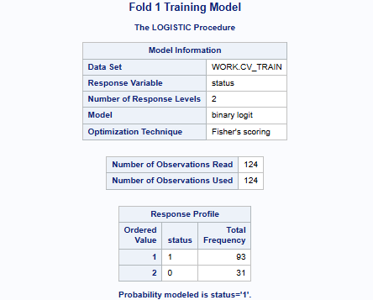

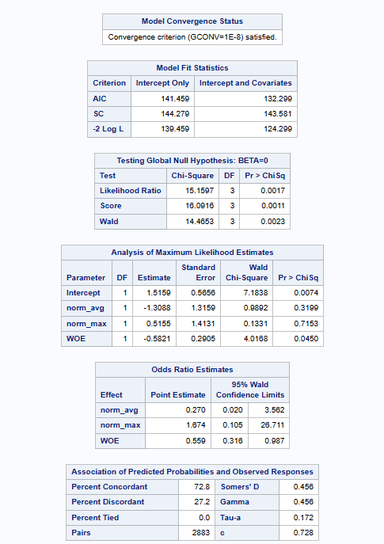
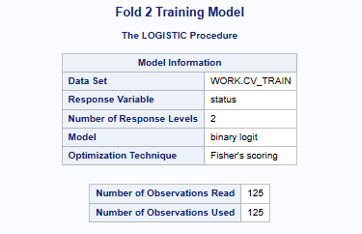

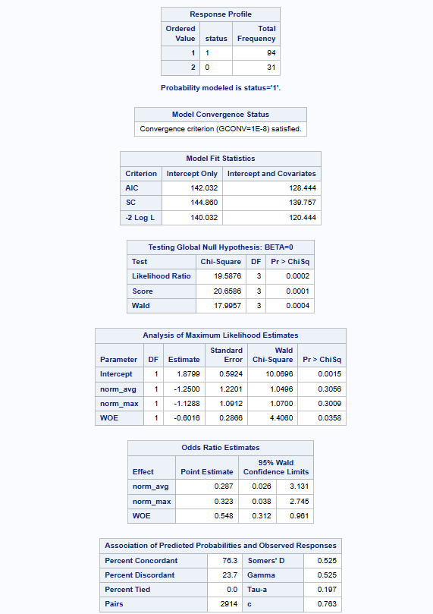

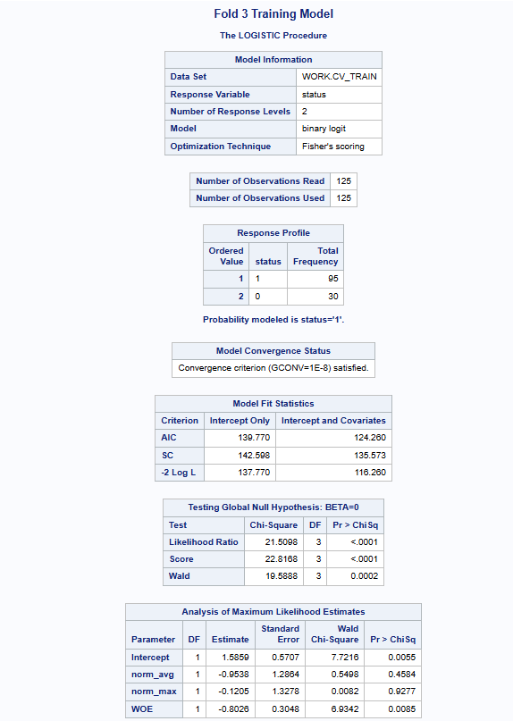

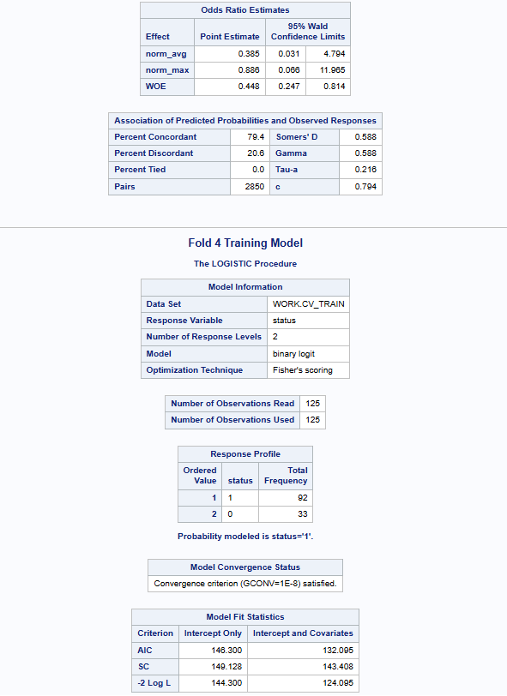

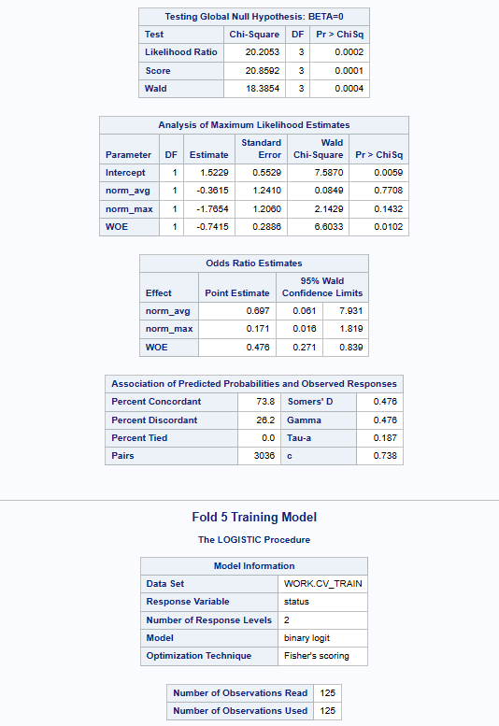

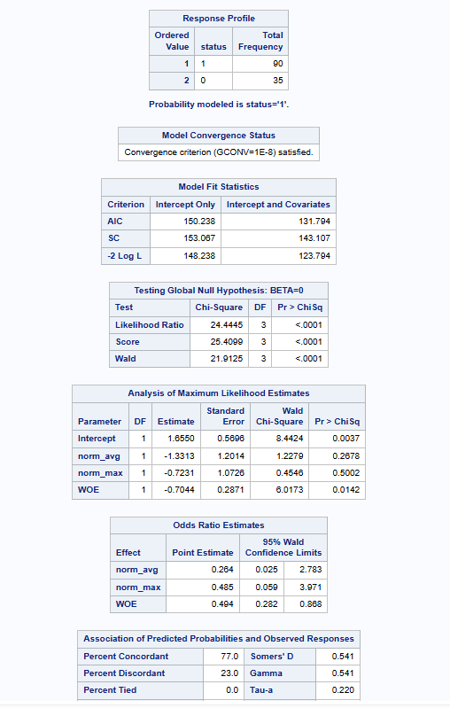

The trained model is applied to test data to generate predicted probabilities (P_1).
These probabilities represent the likelihood that a person has Parkinson’s disease.
Code:
ods output ParameterEstimates=final_coef;
proc logistic data=train_data descending outmodel=model_final;
title "Final Logistic Model";
model status = norm_avg norm_max WOE;
run;
proc print data=final_coef;
title "Final Model Coefficients";
run;
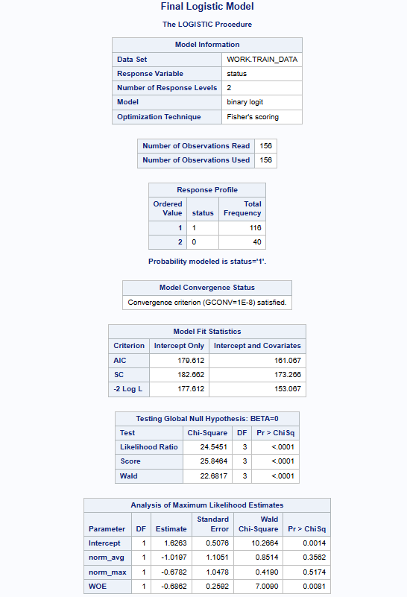
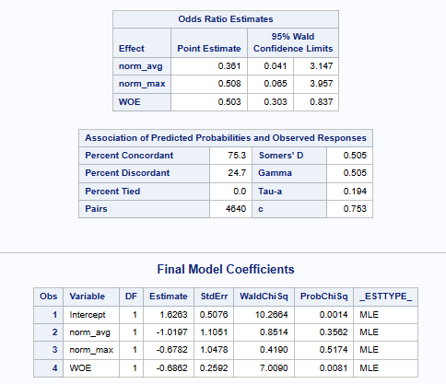
Predictions are converted into binary outcomes using threshold = 0.5.
Evaluation includes:
- Confusion matrix
- Accuracy
- Precision
- Recall
- F1 score
Confusion matrix helps understand:
- True positives
- False positives
- False negatives
- True negatives
Code:
data eval;
set test_scored;
if P_1>=0.5 then pred=1;
else pred=0;
run;
proc freq data=eval;
title "Confusion Matrix";
tables status*pred / norow nocol nopercent;
run;
proc sql;
create table metrics as
select
sum(case when status=1 and pred=1 then 1 else 0 end) as TP,
sum(case when status=0 and pred=0 then 1 else 0 end) as TN,
sum(case when status=0 and pred=1 then 1 else 0 end) as FP,
sum(case when status=1 and pred=0 then 1 else 0 end) as FN
from eval;
quit;
data metrics;
set metrics;
Accuracy = (TP+TN)/(TP+TN+FP+FN);
Precision = TP/(TP+FP);
Recall = TP/(TP+FN);
F1 = 2*(Precision*Recall)/(Precision+Recall);
run;
proc print data=metrics;
title "Evaluation Metrics";
run;

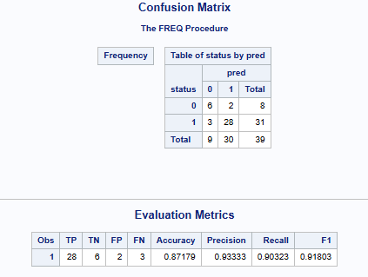
ROC curve shows:
- Trade-off between sensitivity and specificity
AUC (Area Under Curve) measures model performance:
- AUC = 0.5 → random model
- AUC close to 1 → excellent model
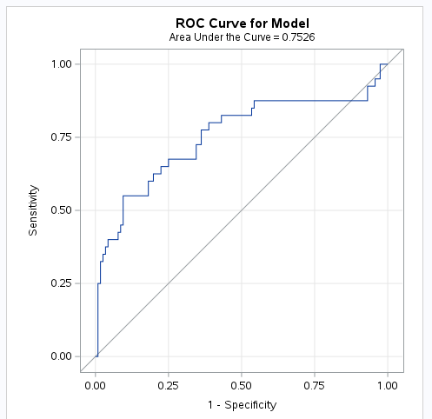
- ROC curve
- AUC output
A new test case is created with sample feature values.
The same transformations (normalization + WOE) are applied, and the trained model predicts whether the patient has Parkinson’s.
This step demonstrates real-world deployment.
Code:
data new_patient;
avg_fre=130;
max_fre=200;
avgfre_bin="Medium";
WOE=0.2;
run;
data new_patient_norm;
if _n_=1 then set norm;
set new_patient;
norm_avg=(avg_fre-min1)/(max1-min1);
norm_max=(max_fre-min2)/(max2-min2);
run;
proc logistic inmodel=model_final;
score data=new_patient_norm out=prediction;
run;
proc print data=prediction;
title "New Patient Prediction";
run;


3. Conclusion
This project successfully demonstrates the use of SAS for predicting Parkinson’s disease using biomedical voice data. The workflow includes data preprocessing, transformation, feature engineering, and advanced modeling techniques such as WOE transformation and k-fold cross-validation.
The logistic regression model was evaluated using multiple performance metrics, including accuracy, precision, recall, F1 score, and AUC. The ROC curve shows that the model performs well in distinguishing between healthy individuals and patients.
The project proves that voice-based features can effectively detect Parkinson’s disease and that SAS provides powerful tools for building complete analytical pipelines. The final model can be used in real-world healthcare systems to assist in early diagnosis.

